Ai powered virtual assistant for virtual facility management

Moschip Digital cloud service

Index

Ai powered virtual assistant for virtual facility management ........................................... 2

Description ........................................................................................................... 3

Model details .........................................................................................................3

Demo requirements ..................................................................................................... 5

Library requires .........................................................................................................5

Environment Setup ....................................................................................................5

For Running the Demo ...............................................................................................5

Ai powered virtual assistant for virtual facility management

## Description

The AI-Powered Virtual Assistant for Facility Management is designed to streamline the process of handling complaints and requests related to various facility management issues. This intelligent chatbot leverages natural language processing (NLP) capabilities to understand user inquiries, categorize issues, and generate tickets for resolution. The assistant operates in a professional and polite manner, ensuring a positive user experience while effectively managing facility-related concerns. The rise of deepfakes poses societal implications, including damage to individual reputations and the spread of false information. There is a growing demand for effective detection tools that can be integrated into social media and content-sharing platforms.

The virtual assistant is equipped to receive and process complaints from users regarding various facility-related issues, such as IT problems, plumbing issues, electrical faults, HVAC concerns, cleaning requests, maintenance needs, security inquiries, and environmental issues.

The chatbot analyzes the semantic content of user complaints to classify them into predefined categories (IT, Plumbing, Electrical, HVAC, Cleaning, Maintenance, Security, Environmental). It further determines specific sub-categories based on the identified asset, ensuring that the right team addresses the issue.

## Model Details

* Source: llama 3.2: 3b (Ollama)
* Framework: Langchain and PIL
* Dataset: NA
* Model Input Shape: Complaint related to any issue in office

User: Hi

Bot: Hello! Please provide me with your complaint so that I can assist you in creating a ticket. What seems to be the issue?

User: Not enough desks in the open area

Bot: It appears there is an issue with the available seating in the open area.

Here's a summary for your reference:

Insufficient Desks in Open Area

Category: Maintenance

Sub-Category: Furniture/Affordability

Bot: Can I raise the ticket?

User:yes

Here is your Ticket ID - Ticket ID: FM-2024-02-20-001

# Demo Requirements

## Library requires

* Operating System – Ubuntu Linux (20.04, 22.04)
* Python == 3.13

## Environment Setup

**For Linux**

Open a new terminal and move to the demo directory using below command

$ cd Ai Assistant

$ conda create –n “chatbot” python=3.13

Use below commands to set environment in Ubuntu

$ conda activate chatbot

$ pip install –-upgrade pip

## For Running the demo

**Commands**

$ cd Ai Asisstant

$ streamlit run app.py

GUI will be displayed as shown in the image below.

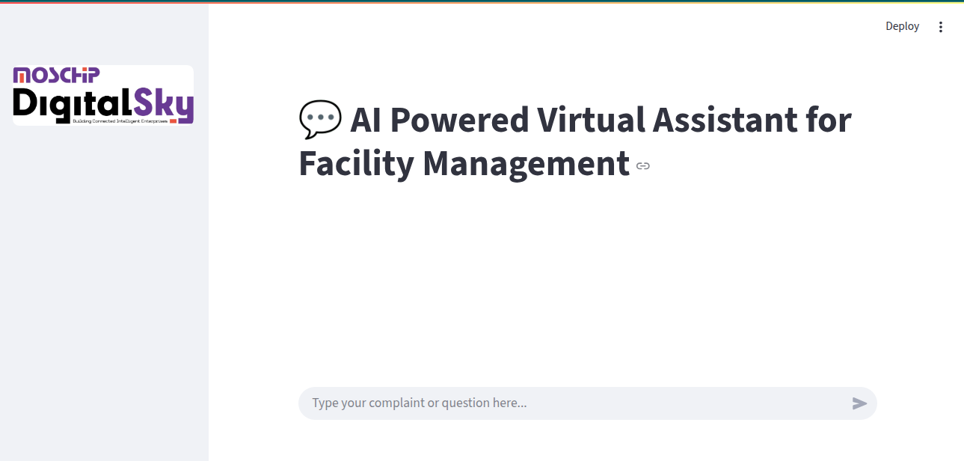

**Enter the Complaints as we enter in chagpt**

**Output window**

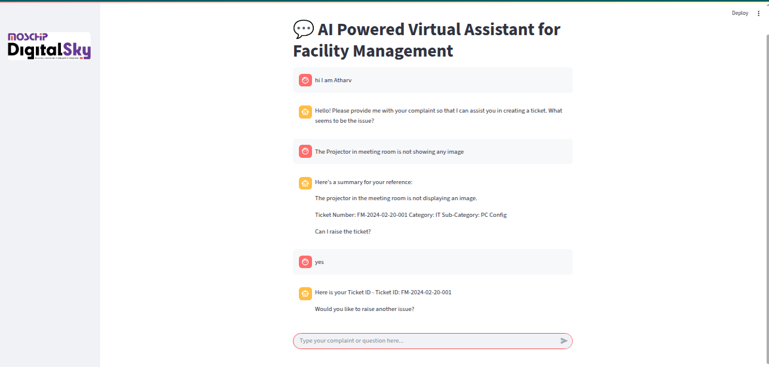I